SOFTWARE TESTING (CSA37)
ASSIGNMENT 2 – CO2
Design and Appraise Black-Box and White-Box Test Cases
for a Personal Loan Eligibility Module (LoanEase)

NAME : Lakshmipathi Deepthi
REG NO: 192411213

Total Marks: 50

Case Study Overview
LoanEase accepts Age (0–120), Monthly Income (Rs.), Credit Score (300–900), Loan Amount (Rs. 50,000–5,00,000) and Tenure (6–84 months). The eligibility function applies the ordered rules shown in the assignment: age 21–60; income at least Rs. 25,000; credit-risk rejection when score < 600 AND income < Rs. 75,000; amount not greater than 20 × income; and tenure not greater than 60 months. Approved applicants receive 9.5% when score ≥ 750, otherwise 11.5%.
Assumptions used throughout: (1) income is a non-negative rupee value; the brief does not state an upper input limit. (2) Input-format/range validation is assumed to occur before assessLoan. (3) The function itself does not explicitly validate score, amount or tenure input ranges; tests for these validations are therefore treated as interface-validation tests unless a direct unit test deliberately bypasses the interface. (4) Rejection order follows the code, so the first failed rule determines the message.

Task 1 – Equivalence Class Partitioning
Equivalence Class Partitioning (ECP) divides the input domain into groups expected to behave similarly. One representative value is selected from each class.
Input | Equivalence class | Representative test input | Expected result
Age | Invalid input range: <0 | -1 | Input validation error
Age | Valid input range but ineligible: 0–20 | 20 | REJECTED – Age out of range
Age | Eligible: 21–60 | 30 | Continue to remaining rules; can be APPROVED
Age | Valid input range but ineligible: 61–120 | 61 | REJECTED – Age out of range
Age | Invalid input range: >120 | 121 | Input validation error
Monthly income | Invalid: negative | -1 | Input validation error
Monthly income | Eligible threshold class: Rs. 25,000 or more | 30,000 | Continue; result depends on other inputs
Monthly income | Below eligibility threshold: Rs. 0–24,999 | 24,999 | REJECTED – Low income
Credit score | Invalid: <300 | 299 | Input validation error
Credit score | Valid lower band: 300–599 | 550 | Credit-risk rejection only if income <75,000
Credit score | Valid upper band: 600–900 | 700 | Passes credit-risk rule
Credit score | Invalid: >900 | 901 | Input validation error
Loan amount | Invalid: <Rs. 50,000 | 49,999 | Input validation error
Loan amount | Valid range: Rs. 50,000–5,00,000 and ≤20× income | 200,000 with income 30,000 | Pass amount rule; continue
Loan amount | Valid input range but >20× income | 500,001 with income 25,000 | REJECTED – Amount too high (direct function test; bypass amount input validation)
Loan amount | Invalid: >Rs. 5,00,000 | 500,001 | Input validation error

Important distinction: Age has two different partitions. The input control accepts 0–120, but eligibility accepts only 21–60. Therefore, ages 0–20 and 61–120 are validly entered values that must be rejected by the business rule; values outside 0–120 are input-validation failures. The same distinction applies to tenure: 6–84 is an accepted input range, while the function only permits 6–60. The loan amount has an accepted input range of Rs. 50,000–5,00,000, while the business rule additionally limits it to 20 times monthly income.
For the table, use common passing values for fields not under test: age 30, income Rs. 40,000, score 700, amount Rs. 200,000 and tenure 36 months, changing only the representative field as needed.

Task 2 – Boundary Value Analysis
BVA concentrates tests at the edges of ranges and thresholds. Two-value BVA uses the value just below and the value at/just above a boundary (depending on the convention); three-value BVA uses boundary −1, boundary, boundary +1. For inclusive limits, the tables below show the three-value neighbourhood and the corresponding two-value subset.
Boundary / rule | 2-value tests | 3-value tests | Purpose
Age lower eligibility = 21 | 20, 21 | 20, 21, 22 | Below, at and above minimum eligible age
Age upper eligibility = 60 | 60, 61 | 59, 60, 61 | At and above maximum eligible age
Income threshold = Rs. 25,000 | 24,999; 25,000 | 24,999; 25,000; 25,001 | Low-income rejection boundary
Loan amount input minimum = Rs. 50,000 | 49,999; 50,000 | 49,999; 50,000; 50,001 | Input validation lower edge
Loan amount input maximum = Rs. 5,00,000 | 5,00,000; 5,00,001 | 4,99,999; 5,00,000; 5,00,001 | Input validation upper edge
Amount rule = 20 × income | 20I; 20I+1 | 20I−1; 20I; 20I+1 | Business-rule limit; use an income that makes values fit input range
Tenure input minimum = 6 | 5, 6 | 5, 6, 7 | Input validation lower edge
Tenure eligibility maximum = 60 | 60, 61 | 59, 60, 61 | Business-rule upper edge
Tenure input maximum = 84 | 84, 85 | 83, 84, 85 | Input validation upper edge

Test count: counting each boundary neighbourhood separately gives 9 boundaries. Two-value BVA = 9 × 2 = 18 tests; three-value BVA = 9 × 3 = 27 tests. If a test design reuses identical test vectors across boundaries, the actual number can be reduced, but these are the straightforward per-boundary counts.
BVA can expose off-by-one defects (>, ≥, <, ≤), incorrect inclusive/exclusive limits, truncation/rounding errors, and wrong handling immediately around a threshold. ECP may select one typical value from a class and miss a defect that occurs only at the class edge.

Task 3 – Decision Table Testing
Conditions: C1 age within 21–60; C2 income ≥ Rs. 25,000; C3 score ≥600 OR income ≥Rs.75,000; C4 amount ≤20×income; C5 tenure ≤60. The rules are evaluated in code order. A dash means the condition is irrelevant because an earlier rule already determines the result.
Rule | C1 | C2 | C3 | C4 | C5 | Expected action
R1 | F | – | – | – | – | REJECTED – Age out of range
R2 | T | F | – | – | – | REJECTED – Low income
R3 | T | T | F | – | – | REJECTED – Credit risk
R4 | T | T | T | F | – | REJECTED – Amount too high
R5 | T | T | T | T | F | REJECTED – Tenure too long
R6 | T | T | T | T | T | APPROVED; rate determined by score

Rule | Example test data (age, income, score, amount, tenure) | Expected result
R1 | 20, 40,000, 700, 200,000, 36 | REJECTED – Age out of range
R2 | 30, 24,000, 700, 200,000, 36 | REJECTED – Low income
R3 | 30, 30,000, 550, 200,000, 36 | REJECTED – Credit risk
R4 | 30, 25,000, 700, 500,001, 36 | REJECTED – Amount too high (direct function test; amount exceeds UI limit)
R5 | 30, 40,000, 700, 200,000, 61 | REJECTED – Tenure too long
R6 | 30, 40,000, 800, 200,000, 36 | APPROVED at 9.5%

The reduced table has six rules. Rule R4 is reachable with valid amount and income values (Rs. 500,000 > 20 × Rs. 30,000).

Task 4 – State Transition Testing
The state model represents the application lifecycle. Rejected, Disbursed and Cancelled are treated as terminal states in this simplified model.
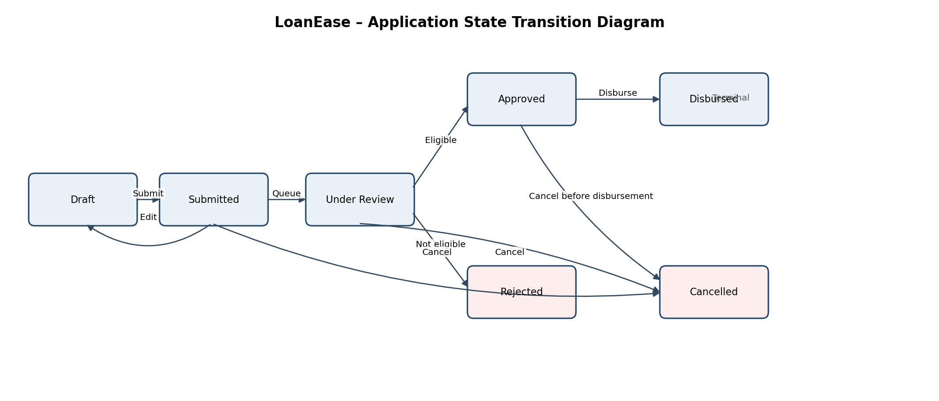
Current state | Event / guard | Next state | Expected system response
Draft | Customer submits complete application | Submitted | Save application; assign application ID
Draft | Customer edits details | Draft | Update draft
Draft | Customer cancels | Cancelled | Mark cancelled; prevent further processing
Submitted | System queues application | Under Review | Record review start and status
Submitted | Customer cancels before review starts | Cancelled | Cancel request and confirm
Under Review | Eligibility checks pass | Approved | Store decision and offered rate
Under Review | Eligibility check fails | Rejected | Store rejection reason
Under Review | Customer cancels before decision | Cancelled | Stop review and confirm cancellation
Approved | Bank disburses funds | Disbursed | Record disbursement reference and date

Test ID | Transition attempted | Expected result
ST1 | Draft → Submitted | Valid; status changes to Submitted
ST2 | Draft → Draft (edit) | Valid; changes saved
ST3 | Draft → Cancelled | Valid; terminal Cancelled
ST4 | Submitted → Under Review | Valid; review begins
ST5 | Submitted → Cancelled | Valid; cancellation recorded
ST6 | Under Review → Approved | Valid when all eligibility rules pass
ST7 | Under Review → Rejected | Valid when an eligibility rule fails
ST8 | Under Review → Cancelled | Valid before decision
ST9 | Approved → Disbursed | Valid; disbursement recorded
ST10 | Disbursed → Draft | Invalid; reject transition, retain Disbursed
ST11 | Rejected → Approved | Invalid; require a new application or formal appeal workflow
ST12 | Cancelled → Under Review | Invalid; retain Cancelled

Task 5 – Random Testing
Generate 1,000 reproducible random records using a fixed seed. Sample age uniformly from 0–120, income from a chosen non-negative operational range (for example Rs. 0–2,00,000), score from 300–900, amount from Rs. 50,000–5,00,000 and tenure from 6–84. Include a small proportion of deliberately malformed/out-of-range values in a separate input-validation campaign; do not mix them with the valid-domain sample. Record every input and output.
Test oracle: implement an independent reference decision function that applies the stated rules in exactly the specified order and compares the expected status, rejection reason and interest rate with the application output. The oracle should not copy the production implementation line-for-line; otherwise the same defect may be duplicated.
- Property 1: for every age <21 or >60, the function must return REJECTED – Age out of range, regardless of other input values.
- Property 2: for every otherwise eligible input with score ≥750, the approved rate must be 9.5%; with score <750, an approved result must carry 11.5%.
Limitation: random sampling may rarely or never generate critical boundary combinations (for example, income exactly Rs. 75,000 with score 599), so it cannot replace ECP, BVA, decision-table and coverage-driven tests.

Task 6 – Pairwise (Combinatorial) Testing
There are four parameters with three values each. Exhaustive testing requires 3⁴ = 81 test cases. Pairwise testing ensures every possible pair of values for every pair of parameters appears at least once. The following 9-case orthogonal array covers all 3×3 value pairs for all six parameter pairs.
Test | Amount | Tenure | Interest type | Repayment mode
1 | Low | Short | Fixed | Auto-debit
2 | Low | Medium | Floating | UPI
3 | Low | Long | Concessional | Cheque
4 | Mid | Short | Floating | Cheque
5 | Mid | Medium | Concessional | Auto-debit
6 | Mid | Long | Fixed | UPI
7 | High | Short | Concessional | UPI
8 | High | Medium | Fixed | Cheque
9 | High | Long | Floating | Auto-debit

The 9-case set is much smaller than 81 because it targets all two-parameter interactions rather than every four-parameter combination. Pairwise testing is efficient when most interaction defects are caused by pairs of settings; it does not guarantee detection of defects that require a specific three-way or four-way combination.

Task 7 – Statement and Branch Coverage
Given tests: T1=(25, 30,000, 700, 200,000, 36); T2=(15, 30,000, 700, 200,000, 36); T3=(30, 20,000, 700, 200,000, 36). Count each of the five if-decisions, five rejection returns, the rate assignment and the final approval return as 12 executable statements.
Coverage item | Executed by T1–T3? | Reason
Five if decision statements (lines 2–6) | All 5 | T1 passes through all five decisions
Age rejection return | Yes | T2
Low-income rejection return | Yes | T3
Credit-risk / amount / tenure rejection returns | No | No test reaches these rejection branches
Rate assignment and final approval return | Yes | T1

Statement coverage = 9 / 12 × 100 = 75%. The 9 executed statements are the five decision statements, age rejection return, low-income rejection return, rate assignment and final approval return.
Decision | True branch covered? | False branch covered?
Line 2: age invalid | Yes (T2) | Yes (T1/T3)
Line 3: income low | Yes (T3) | Yes (T1)
Line 4: credit risk | No | Yes (T1)
Line 5: amount too high | No | Yes (T1)
Line 6: tenure too long | No | Yes (T1)

Branch coverage = 7 / 10 × 100 = 70%. Uncovered branches: true branches of lines 4, 5 and 6.
Smallest additional set: three tests are required because each rejection branch must be reached separately and an earlier rejection prevents reaching a later rule. A1=(30, 30,000, 550, 100,000, 36) reaches line 4 true; A2=(30, 25,000, 700, 500,001, 36) reaches line 5 true; A3=(30, 40,000, 700, 200,000, 61) reaches line 6 true. Combined with T1–T3, this covers all 10 branches. A2 deliberately bypasses the front-end amount-range validator because the line-5 branch is unreachable for inputs within all stated valid domains.

Task 8 – Condition, Decision and MC/DC Coverage
For line 4, let A = (score < 600), B = (income < Rs. 75,000), and decision D = A AND B.
Test | Score | Income (Rs.) | A | B | D = A AND B | Expected line-4 effect
M1 | 550 | 30,000 | T | T | T | Credit-risk rejection
M2 | 700 | 30,000 | F | T | F | Continue
M3 | 550 | 75,000 | T | F | F | Continue

Decision coverage requires 2 tests: one where D is true (M1) and one where D is false (M2 or M3). Condition coverage requires 3 tests here so that A is both true and false and B is both true and false (M1–M3). MC/DC also requires 3 tests: M1 vs M2 shows A independently changes D while B remains true; M1 vs M3 shows B independently changes D while A remains true.
There are four possible combinations (TT, TF, FT, FF), but MC/DC does not require all four. It requires each atomic condition to be shown independently to affect the decision, so three carefully selected tests are sufficient. It is stronger than decision coverage because it demonstrates the independent influence of each condition.
Task 9 – Control Flow Graph and Cyclomatic Complexity
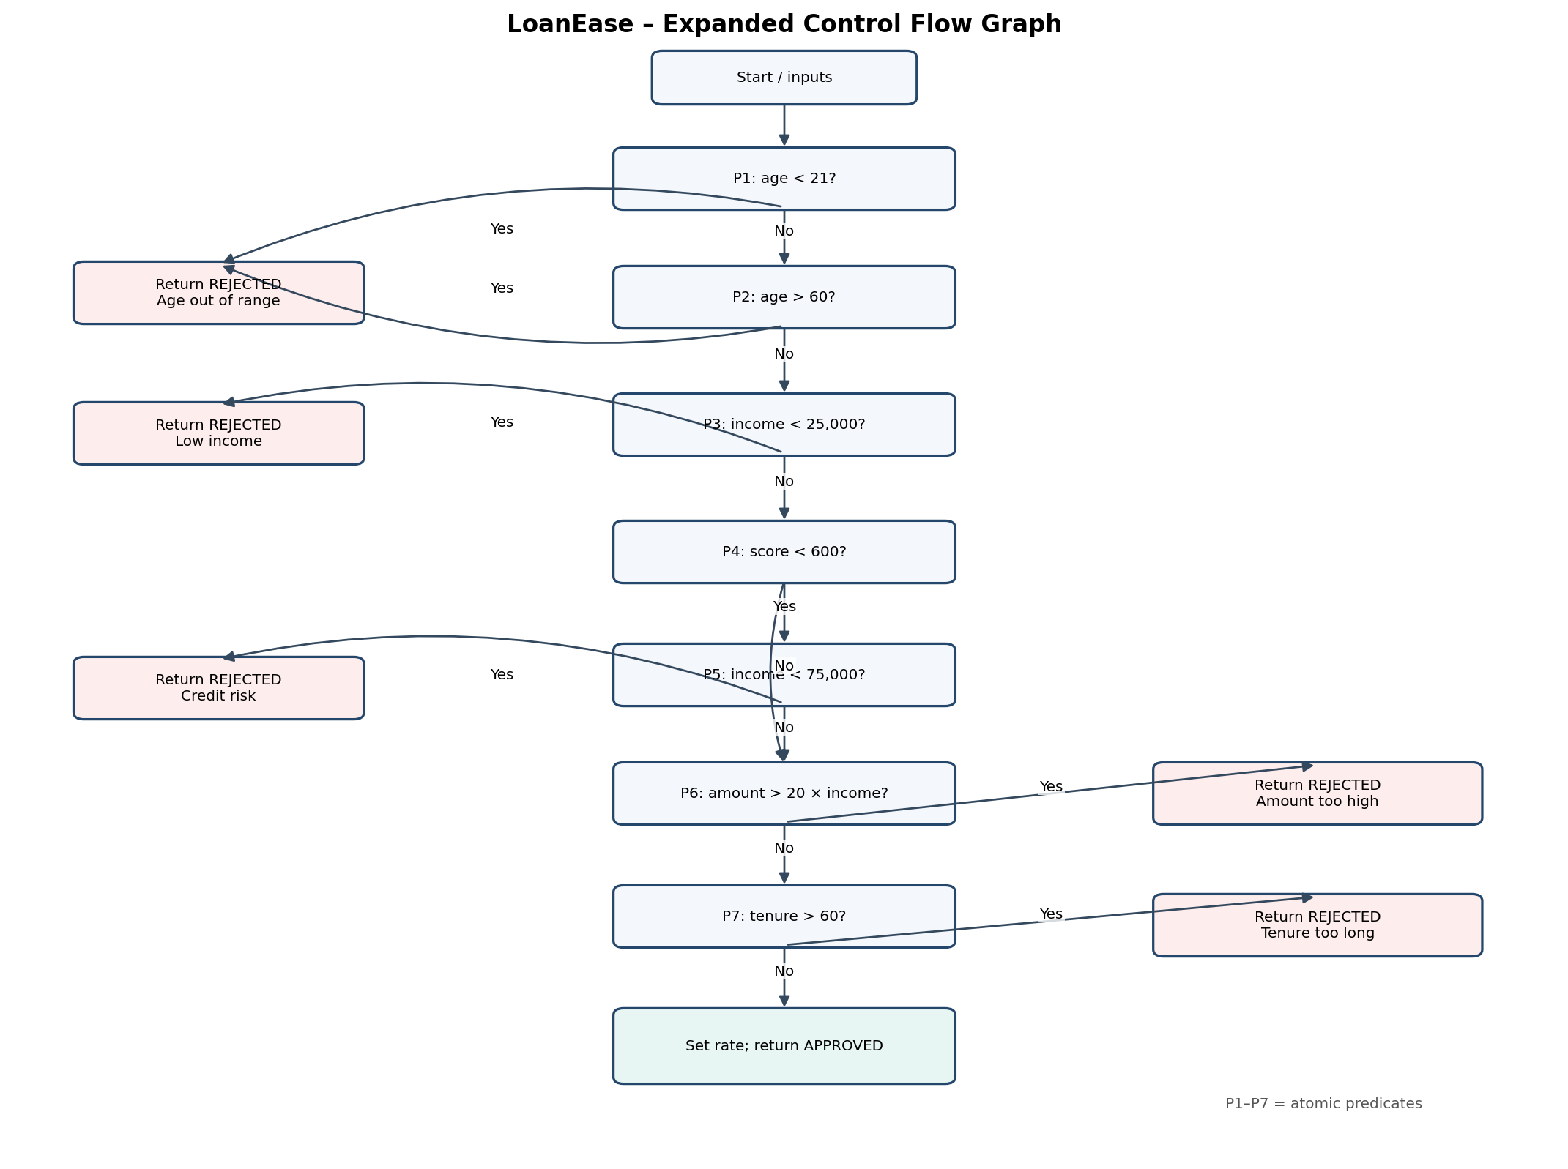
The expanded graph contains seven atomic predicate nodes: age <21; age >60; income <25,000; score <600; income <75,000; amount >20×income; and tenure >60. Therefore, V(G) = number of predicate nodes + 1 = 7 + 1 = 8.
Using V(G)=E−N+2P, with one connected component (P=1), the expanded graph has E−N=6, so V(G)=6+2=8. The same result is obtained by counting the seven atomic predicates and adding one.
If the compound expressions on lines 2 and 4 are each represented as a single decision node, there are only five decision nodes (lines 2–6), giving V(G)=5+1=6. That is a coarser graph which hides the internal true/false outcomes of the OR and AND expressions. Expanding the two compound conditions adds two predicate nodes and raises the complexity from 6 to 8.

Task 10 – Path Testing (4 Marks)
A basis set contains V(G)=8 linearly independent paths. The tests below exercise the eight independent paths in the expanded graph. Values are chosen so that earlier checks pass unless the path is intended to exit.
Path | Path condition / route | Test input (age, income, score, amount, tenure) | Expected output
P1 | age <21 → age rejection | 20, 40,000, 700, 200,000, 36 | REJECTED – Age out of range
P2 | age ≥21 then age >60 → age rejection | 61, 40,000, 700, 200,000, 36 | REJECTED – Age out of range
P3 | age valid; income <25,000 | 30, 24,999, 700, 100,000, 36 | REJECTED – Low income
P4 | age/income pass; score <600 and income <75,000 | 30, 30,000, 550, 100,000, 36 | REJECTED – Credit risk
P5 | age/income pass; score ≥600; amount/tenure pass | 30, 40,000, 700, 200,000, 36 | APPROVED at 11.5%
P6 | age/income pass; score <600 but income ≥75,000; amount/tenure pass | 30, 80,000, 550, 200,000, 36 | APPROVED at 11.5%
P7 | prior rules pass; amount >20× income (direct function test) (requires bypassing the amount input limit) | 30, 25,000, 700, 500,001, 36 | REJECTED – Amount too high
P8 | prior rules pass; amount passes; tenure >60 | 30, 40,000, 700, 200,000, 61 | REJECTED – Tenure too long

The number of independent paths is eight, equal to V(G)=8. This is a basis set, not a claim that every possible execution path has been enumerated; loops are absent, but compound decisions create additional combinations.

Task 11 – Test Adequacy and Coverage Gap Analysis (4 Marks)
100% statement coverage only proves that every executable statement ran at least once. It does not prove that boundary values, both sides of decisions, condition independence, error handling or exact comparisons were tested. A mutant can survive when the suite executes the mutated line but never supplies an input that distinguishes the original and mutated behaviour.
The survivor changes income <75,000 to income ≤75,000. To kill it, use score <600 and income exactly Rs. 75,000. Original code evaluates the income condition as false and does not reject for credit risk; mutated code evaluates it as true and rejects.
Additional test | Input / setup | Mutant targeted | Expected original behaviour
MUT1 | Age 30, income Rs. 75,000, score 599, amount Rs. 200,000, tenure 36 | < changed to ≤ at income threshold | Credit-risk condition is false; proceed and APPROVE at 11.5%
MUT2 | Age 21, income Rs. 40,000, score 700, amount Rs. 200,000, tenure 60 | Age lower/upper comparison mutant (e.g. age ≤20 or age ≥60) | APPROVED at 11.5%; catches incorrect boundary inclusivity at age 21 / tenure 60
MUT3 | Age 30, income Rs. 30,000, score 700, amount exactly Rs. 600,000, tenure 36 (direct function test) | Amount comparison > changed to ≥ | Amount equals 20× income; must pass amount rule

Release adequacy proposal: require 100% statement and branch coverage for reachable code, 100% MC/DC for safety/financial eligibility compound decisions, all specified ECP classes and BVA boundaries, complete valid-transition coverage plus invalid-transition checks, and a mutation score of at least 90% for non-equivalent mutants. Every surviving mutant must be reviewed and either killed by a test or documented as equivalent/unreachable. Also require no open critical/high-severity defects.

Task 12 – Integrated Test Suite Design Challenge (8 Marks)

A. Integrated Test Suite and Traceability (2 Marks)
The integrated regression suite reuses the tests already defined above. Each requirement is linked to its test identifiers and the technique used to derive them.
Requirement / risk | Mapped tests | Technique / evidence
Age input range and eligibility 21–60 | ECP age classes; BVA age 20/21/22 and 59/60/61; T2; P1–P2 | ECP, BVA, statement/branch, path
Income minimum Rs. 25,000 | ECP income classes; BVA 24,999/25,000/25,001; T3; P3 | ECP, BVA, branch, path
Credit-risk compound rule | R3; M1–M3; MUT1; P4 and P6 | Decision table, MC/DC, mutation, path
Loan amount input and 20×income rule | ECP amount classes; BVA amount boundaries; R4; A2; MUT3; P7 | ECP, BVA, decision table, branch, path
Tenure input 6–84 and eligibility ≤60 | ECP tenure classes; BVA 5/6/7, 59/60/61, 83/84/85; R5; A3; P8 | ECP, BVA, decision table, branch, path
Interest-rate assignment | T1; P5; P6; score 749/750/751 boundary tests | BVA, statement, path
Application lifecycle | ST1–ST12 | State transition testing
EMI parameter interactions | Pairwise tests 1–9 | Pairwise combinatorial testing
General input combinations | 1,000 seeded records and properties | Random / property-based testing
Control-flow adequacy | T1–T3 plus A1–A3; P1–P8; M1–M3 | Statement, branch, MC/DC, path, mutation

B. Adequacy Evaluation and Remaining Gaps (2 Marks)
Technique | Reported adequacy | Remaining gap / action
ECP | Representative classes identified for each input | Add explicit income upper/format classes and invalid tenure/score/amount tests at API boundary
BVA | Nine boundary neighbourhoods; 18 two-value or 27 three-value tests | Add rate boundary score 749/750/751 and amount dynamic boundary using several incomes
Decision table | 6/6 reduced rules represented | Add tests for the 9.5% and 11.5% approval-rate outcomes
State transition | 9 valid transitions and 3 invalid transitions tested | Confirm whether business permits cancellation after approval; model additional states if required
Pairwise | 9 tests cover all pairs for 4 three-valued parameters | Does not guarantee 3-way/4-way interaction coverage
Statement | Given suite: 75%; add A1–A3 for full executable statement coverage | Clarify unreachable statements and validation code in the complete implementation
Branch | Given suite: 70%; A1–A3 cover remaining true branches | Instrument actual code and confirm all branches are reachable
MC/DC | 3 tests for line 4 | Apply MC/DC to other compound decisions if introduced; age OR can be independently tested too
Path | 8 independent paths for expanded graph | Basis paths do not cover every possible combination of all input values

C. External Credit-Score Service – Design Revision
Scenario | Test design / input condition | Technique | Expected result
Service time-out | Stub the score service to delay beyond configured timeout | Negative testing, fault injection, state transition | Do not approve using a missing score; show retryable service error or move application to Pending/Manual Review; log timeout and correlation ID
Score outside 300–900 | Stub returns 299 and then 901 | ECP and BVA | Reject/flag invalid external response; do not pass the invalid score into assessLoan; log provider response safely
Malformed response | Return empty body, invalid JSON, missing score field, string instead of number, or null | Robustness / negative / interface contract testing | Handle parsing/validation error safely; no crash and no approval; record a controlled integration error
Service unavailable / repeated failure | Return 5xx or connection reset | Fault injection and recovery testing | Bounded retry with backoff; no duplicate application/disbursement; retain application state
Valid service response | Return score 300, 600, 749, 750 and 900 | Contract testing and BVA | Accept valid scores; eligibility and interest rate follow the documented rules

The score service should be isolated behind a mock/stub so tests are deterministic. Add contract tests against the provider's schema in a separate integration environment. Never use a default score of zero or silently treat a failed call as a low-risk score.

D. Evidence-Based Defence and Best Value
Technique | Defects detected / risk reduced | Relative effort
ECP | Missing or incorrect handling of distinct valid/invalid input classes | Low
BVA | Off-by-one errors at age, income, amount, tenure and score thresholds | Low–medium
Decision table | Wrong precedence, missing rule combinations, incorrect rejection reason | Medium
State transition | Illegal lifecycle jumps, cancellation/disbursement errors | Medium
Pairwise | Common two-parameter interaction defects in EMI settings | Low–medium
Random / property-based | Unexpected combinations, crashes and violated invariants | Low after harness is built
Statement / branch / MC/DC / path | Untested code, missing branches, compound-condition logic errors | Medium–high
Mutation testing | Weak assertions and tests that execute code without detecting logic changes | Medium–high
Fault injection / contract tests | Timeout, malformed provider data, invalid score, retry and recovery defects | Medium

Best value for a team of two testers: a risk-focused combination of BVA plus decision-table testing gives the strongest value for the core loan eligibility logic. BVA is inexpensive and catches common comparison defects; the decision table systematically checks rule precedence and combinations. For the new external service, add a small set of stubbed fault-injection and contract tests because integration failure can create serious financial and operational risk. Coverage and mutation testing should then be used as evidence that the suite is not merely executing code but detecting defects.

Conclusion
LoanEase requires both black-box and white-box testing. ECP, BVA, decision tables, state transitions, pairwise and random testing examine behaviour from the user's and system's perspective. Statement, branch, MC/DC, control-flow, path and mutation testing examine the implementation and the strength of the tests. The integrated approach improves confidence in eligibility decisions, loan lifecycle handling and resilience to external credit-service failures.

